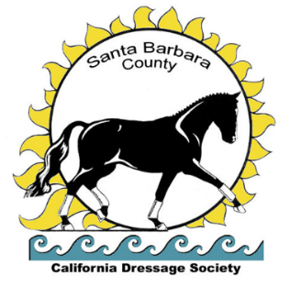 The **Santa Barbara County Chapter** offers clinics and educational events throughout the year in addition to our two rated annual shows at the legendary **Earl Warren Showgrounds** with outstanding footing. Join us for our tasty BBQ Saturday and our illustrious Champagne Class.

**Spring Dressage in Santa Barbara**

Judges: Beverly Rogers and Melissa Creswick

May 17-18, 2025

**Summer Dressage in Santa** **Barbara**

Judges: TBD

August 16-17, 2025

Host to the Parker Equine Insurance

***CDS Regional Adult Amateur Competition***

***~ Central ~***

Our shows are CDS, USDF, USEF recognized.

AQHA recognized for points. *Central Coast Awards Program Qualifiers.* Prize list on our website or

*Online entries:*  [**https://entry.foxvillage.com**](https://entry.foxvillage.com/)

**SBC CDS Virtual Shows**

**Consider a Virtual Show to prepare for your show season. Ride your test at home and receive your test via email. A great inexpensive, convenient opportunity to review your test with an ‘S’ judge before you take it to the rated shows.**

**April 19-21 and August 2-4, 2025**

[**https://VirtualHorseSport.com**](https://VirtualHorseSport.com)

Questions? Email us at [SBCCDSShows@gmail.com](mailto:SBCCDSShows@gmail.com)

**Stay up to date via our website:** [**www.sbccds.org**](http://www.sbccds.org/)

**Follow us on Facebook:** [**https://www.facebook.com/sbdressage**](https://www.facebook.com/sbdressage)